

**Software Requirements Specification (SRS)**

**for**

**Online Voting Management System**

Version 1.0 Loaded

February 14, 2025

|  |  |
| --- | --- |
| **Roll No** | **Name** |
| **422112** | **Atukuri Maithili** |
| **422129** | **Chevvu Purushotham** |
| **422176** | **Kota Venkata Charan Teja** |

**Table Of Contents**

|  |  |  |
| --- | --- | --- |
|  | |  |
| **1. Introduction** | |  |
| 1.1 Purpose | | 3 |
| 1.2 Scope | | 3 |
| 1.3 Definitions, Acronyms, and Abbreviations | | 3 |
| 1.4 References | | 3 |
|  | |  |
| **2. Overall Description** | |  |
| 2.1 Product Perspective | | 4 |
| 2.2 Product Functions | | 4 |
| 2.3 User Characteristics | | 4 |
| 2.4 Operating Environment | | 4 |
| 2.5 Constraints | | 5 |
| 2.6 Assumptions and Dependencies | | 5 |
|  | |  |
| **3. Specific Requirements** | |  |
| 3.1 Functional Requirements | |  |
|  | 3.1.1 User Registration and Authentication | 6 |
|  | 3.1.2 Voting Process | 6 |
|  | 3.1.3 Election Management | 6 |
|  | 3.1.4 Result Display | 6 |
| 3.2 Non-Functional Requirements | |  |
|  | 3.2.1 Performance Requirements | 6 |
|  | 3.2.2 Security Requirements | 6 |
|  | 3.2.3 Usability Requirements | 6 |
|  | |  |
| **4. System Models** | |  |
| 4.1 Use Case Diagram | | 7 |
| 4.2 Sequence Diagram | | 8 |
| 4.3 Class Diagram | | 8 |
| 4.4 Activity Diagram | | 9 |
| 4.5 State Chart Diagram | | 9 |
| 4.6 Component Diagram | | 10 |
|  | |  |
| **5. Project Contributions** | | 11 |
|  | |  |
| **6. Conclusion** | |  |
| Future Enhancements | | 11 |
|  | |  |
| **7. Appendix** | | 11 |

**1. Introduction**

**1.1 Purpose**

This document specifies the software requirements for the **Online Voting Management System (OVS)**, a platform designed to modernize elections by providing a secure, transparent, and eﬃcient online voting system. The system aims to increase voter participation, ensure compliance with legal requirements, and enhance confidence in electoral outcomes.

**1.2 Scope**

OVS is a web-based platform that allows voters to cast their votes online securely. The system ensures transparency, integrity, and compliance with local and national election laws. It simplifies the voting process, making it more accessible and encouraging higher voter turnout.

**1.3 Definitions, Acronyms, and Abbreviations**

* *OVS* - Online Voting Management System
* *UI* - User Interface
* *Admin* - Election administrator responsible for managing elections
* *Voter* - Registered user eligible to vote in elections
* *PHP* - Backend programming language used
* *MySQL* - Database for storing election-related data

**1.4 References**

* IEEE Standard 830-1998 for Software Requirements Specification

**2. Overall Description**

**2.1 Product Perspective**

OVS is a self-contained platform designed to facilitate secure and eﬃcient online voting. It consists of:

 **Frontend**: Built using HTML, CSS, and JavaScript for user interaction.

 **Backend**: Developed using PHP and Apache Server for managing business logic.

 **Database**: MySQL for storing voter data, election details, and results.

**2.2 Product Functions**

* *Voter Module:*
  + Register/Login
  + Cast a Vote
  + View Election Results
* *Admin Module:*
  + Manage Voter Registrations
  + Set Up Elections
  + View & Publish Election Results

**2.3 User Characteristics**

* *Voters:* Basic knowledge of web navigation, access via a web browser.
* *Admins:* Election officers responsible for managing voters and results.

**2.4 Operating Environment**

* Hardware: Designed for web servers and cloud hosting environments. Supports desktop and mobile devices.
* Software:
  + Frontend: HTML, CSS, JavaScript.
  + Backend: PHP, Apache Server.
  + Database: MySQL.

**2.5 Constraints**

* Requires *stable internet connectivity*.
* Developed using *HTML, CSS, JavaScript, PHP, and MySQL*.
* Must comply with *legal election requirements*.

**2.6 Assumptions and Dependencies**

* *Stable internet connectivity for users.*
* *Basic familiarity with web applications among users.*
* *Reliance on secure authentication mechanisms for voter verification.*

**3. Specific Requirements**

**3.1 Functional Requirements**

**3.1.1 User Registration and Authentication**

* Users shall register using a unique ID and password.
* The system shall verify voter identity before granting access.

**3.1.2 Voting Process**

* Voters shall be able to view ongoing elections.
* Each voter shall be able to cast a vote *only once per election*.

**3.1.3 Election Management**

* Admins shall create and configure elections.
* Admins shall manage voter lists and approve registrations.

**3.1.4 Result Display**

* The system shall generate and display election results after the voting period ends.
* Results shall be available to both voters and admins.

**3.2 Non-Functional Requirements**

**3.2.1 Performance Requirements**

* The system shall support *simultaneous voting by multiple users*.
* Election results should be generated within *10 seconds of voting closure*.

**3.2.2 Security Requirements**

* The system shall implement *secure authentication mechanisms*.
* Votes shall be encrypted and stored securely to prevent tampering.

**3.2.3 Usability Requirements**

* The UI shall be *simple and accessible* to all users.
* The system shall support *mobile-friendly* access.

**4. System Models**

**4.1 Use Case Diagram**

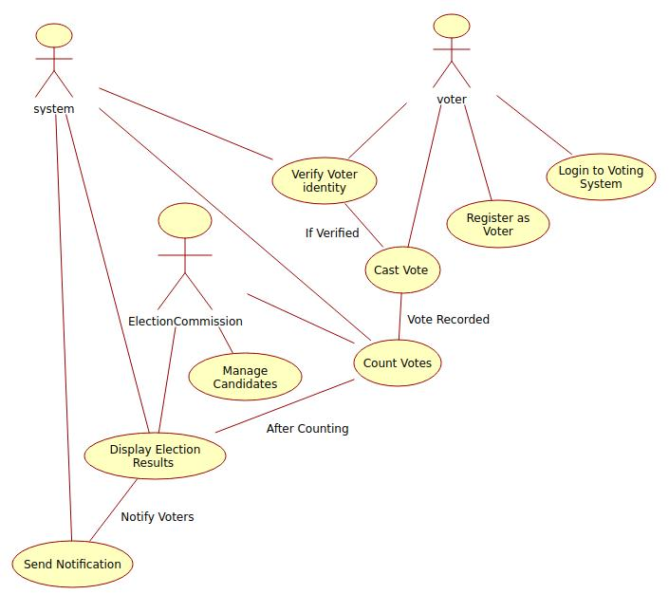

**4.2 Class Diagram**

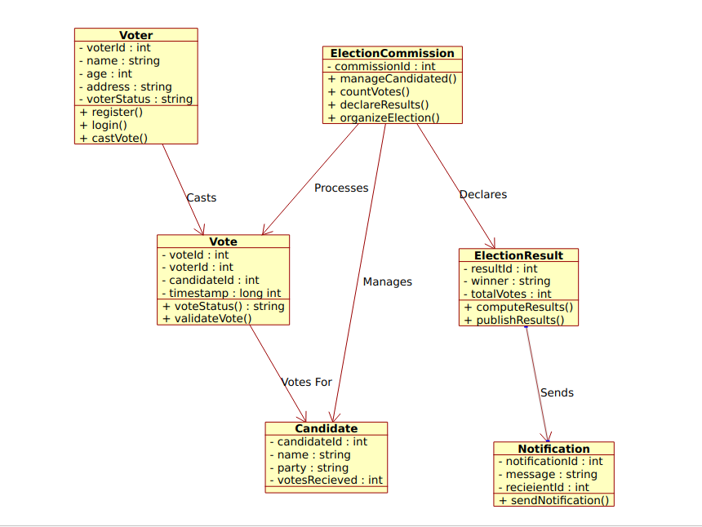

**4.3 Sequence Diagram (Voting Process)**

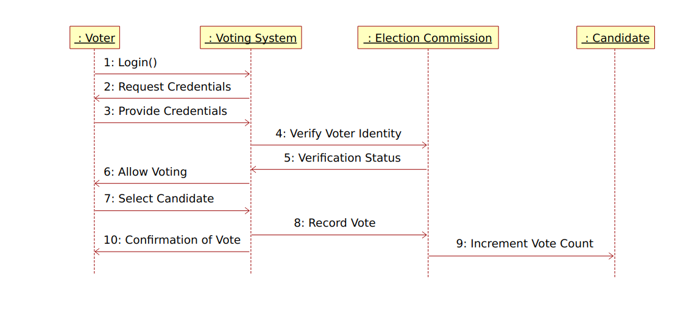

**4.4 Activity Diagram**

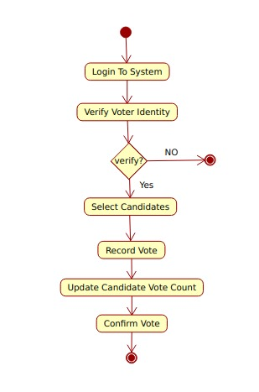

**4.5 State Chart Diagram**

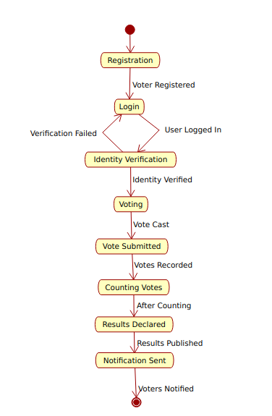

**4.6 Component Diagram**

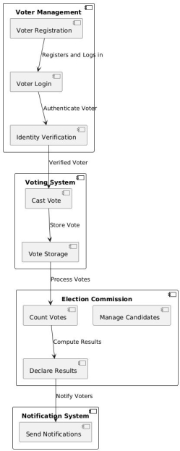

**5. Project Contributions**

|  |  |  |
| --- | --- | --- |
| **Name** | **So far** | **Future** |
|  |  |  |
| Atukuri Maithili | SRS Documentation | Front-end Development, Testing Part |
|  | Use Case Diagram |
|  |  |
| Chevvu Purushotham | State Chart Diagram | Front-end Development, Testing Part |
|  | Activity Diagram |
|  |  |
| Kota Venkata Charan Teja | Component Diagram | Front-end Development,  Back-end Development, Testing Part |
|  | Class Diagram |
|  | Sequence Diagram |
|  |  |

**6. Conclusion**

The *Online Voting Management System (OVS)* aims to modernize the electoral process by providing a *secure, efficient, and transparent* voting mechanism. It enhances voter participation and ensures compliance with election laws.

**Future Enhancements**

* Integration of *biometric authentication* for voter verification.
* Expansion to *mobile applications* for iOS and Android.
* AI-based *fraud detection mechanisms*.

**7. Appendix**

1. PHP Documentation: Accessible at [PHP Oﬃcial Documentation](https://www.php.net/docs.php).
2. MySQL Documentation: Available at [MySQL Oﬃcial Documentation](https://dev.mysql.com/doc/).